PROJECT SPECIFICATION
Analysing Global Cyber Threat Trends Using Distributed Honeynets
Rihards Ozols – C00281617
BSc (Hons) in Cybercrime and IT security

Table of Contents
1. Introduction 1
2. Background 1
2.1 Problem statement 2
2.2 Deliverables 3
2.2.1 Core Deliverables 3
2.2.2 Secondary deliverables 4
3. Project Plan 4
3.1 Methodology 4
3.2 Phases & Timeline 5
3.3 Milestones 8
4. Analysis 9
5. References 10

Introduction
This project investigates global attack patterns and behaviours observed through the deployment of a distributed honeynet architecture across multiple regions and cloud service providers. The aim is to analyse how the frequency, type, and persistence of cyber-attacks differ based on geographical region ; Virginia, Frankfurt, Tokyo, and Singapore and cloud platform —Azure, AWS, and Alibaba Cloud.

Background
What is a honeynet
A honeynet is a network deliberately set up to mimic a real operational network with systems, services and applications but it’s isolated and monitored so that any traffic that passes through it, is assumed suspicious.
Its primary purpose is to attract attackers or exploit attempts, allowing us to observe attacker behaviour, tools, techniques and motivations in a controlled environment.
The deployment of honeypots has been the means of observing the malicious attacker’s behaviour, strategy and mindset and has aided in the understanding of emerging threats. Early honeypot research such as [2], focused on single-node traps for collecting exploit payloads and understanding the attacker’s methodologies. Over time, this evolved into honeynets, an interconnected networks of honeypots designed to emulate realistic infrastructure and observe broader attack strategies. Modern research has examined the distribution of attack traffic across geographic and infrastructural boundaries. Studies at [1] and at [3] demonstrated that statistical analysis of honeypot data could identify systemic attack features, such as characteristic byte distributions or packet frequencies. Later work in 2015[4], introduced honeypots in virtualized and cloud environments, identifying unique attacker behaviours that emerge from differences in IP reputation and hosting provider policies. However, few studies have conducted simultaneous cross-region (Virginia, Frankfurt, Tokyo, and Singapore) and cross-provider comparisons, especially across commercial cloud platforms (AWS, Azure, Alibaba).

2.1 Problem statement
While honeypots and honeynets have long served as valuable tools for understanding attacker behaviour and emerging cyber threats, existing research has largely focused on localized or single-provider environments. Although prior studies have explored aspects such as exploit payload analysis, attack frequency distributions, and virtualized honeypot deployments, there remains a significant gap in comparative analysis across diverse cloud platforms and geographic regions.
When deciding where to host a public-facing website or application, the usual guideline is to host it in your own region (for example: host in Asia if you are based in Asia, host in the Americas if you are there). What we want to investigate is whether hosting in a more secure region rather than locally, offers enough security benefits to justify the extra cost.
This project fills that gap by deploying uniform honeynet environments across multiple providers to assess how attacker behaviour and strategies differs depending on geographic region and platform type.

2.2 Deliverables

2.2.1 Core Deliverables
Virtual Machines (VMs)
The project establishes virtual machine (VM) infrastructure, with each VM designed to host honeynet environments across multiple regions and cloud providers. The honeynets will be hosted on AWS, Azure, and Alibaba Cloud using Modern Honey Network (MHN) software and placed across strategically picked regions.

Dashboard
The dashboard is fully built, data feeds from the honeynets and other sources are connected

Data collection
Have a successful deployment and run period of honeynets, Data extracted from logs and transferred into dashboard.

Non-system-specific Core Deliverables
Methodology
In this section I describe the environments and regions selected for my honeynets and the rationale behind those choices. I outline the strategy for data collection and analysis, and explain how I intend to present the results of my findings.

Research Journal
My weekly research journal will record notable honeynet events (e.g. spikes in traffic, repeated source Ips, etc), Security incidents or global cyber events (e.g. DDoS campaigns, vulnerability disclosures, etc). Regional or geopolitical developments near each data centre region that may explain fluctuations in attack behaviour. These entries provide contextual metadata useful for later correlation with observed attack patterns.

Weekly checklist
A standardized weekly checklist will be completed for all honeynet nodes to ensure all honeypots are online and reachable, Log forwarding to the central server is functional, Disk/storage usage is below any critical thresholds and backup scripts executed successfully.

Analysis
The analysis will involve processing the data captured by the honeynet VMs to identify patterns of attacker behaviour, tools used, exploited services and geographic sources of attacks. I will examine timestamps, IP addresses (both attacker and honeynet), targeted ports/services and duration of sessions to build a timeline and profile of each intrusion. Then I will compare across regions and providers to determine whether attacker strategies differ by location or cloud environment. Finally I will visualise key findings (for example graphs of attack frequency by hour/day, heat-maps of origin countries, and service-target distribution) on my dashboard and interpret how these insights can improve future honeynet deployments and organisational defensive posture. I will also address all questions and hypotheses that I presented in the beginning of this report

2.2.2 Secondary deliverables
Interactive Dashboard User Guide
a user guide/manual explaining how to use the dashboard, what each metric means, how to interpret results.

Provider & Region Risk Profile Catalogue
For each cloud provider and region (AWS Virginia, Azure Frankfurt, Alibaba Cloud Tokyo, etc) produce a risk profile: e.g., IP reputation, historical attack volume, legal/regulatory environment, provider policies
Project Journey Report
This report will be completed at the end of my Project and will talk about any issues or complications I encountered while trying to compile this research project, I will mention technical constraints that could’ve influenced my findings and things I would do differently if I had to start this project from scratch.

Project Plan
In this section, I will explain the platform I’ve selected to host my honeynets, how it operates, and the specific cloud providers and regions I’ve chosen, including the reasons behind those choices.
I will also describe the architecture of my honeynets and provide an estimated cost of running them all.
Next, I’ll talk about particular network ports I’m focusing on in order to gain a deeper understanding of an attacker’s mindset, and how that mindset shifts depending on their region of origin.
Finally, I will walk through my dashboarding tool and outline the different phases of the project along with a timeline and mention some key milestones I aim to achieve.

3.1 Methodology
The cloud providers I chose are AWS, Azure and Alibaba Cloud, I've selected these because they each differ in terms of security frameworks and infrastructure, providing a broad spectrum of environments in which to deploy my honeynets. Although they are based on opposite side of the world from one another, they share a couple of major data centres that are well distributed across the globe. Each cloud provider will host four low-interaction honeypots using the Modern Honey Network (MHN) framework for a total of 80 days. These honeypots will be distributed across four regions(data centres) Virginia, Frankfurt, Tokyo, and Singapore. The cost of hosting these honeypots vary across each cloud provider and will be further investigated in the coming weeks.
Each honeypot will expose common high-interest ports (e.g., 22, 23, 80, 443, 445, 3389) and emulate vulnerable services to attract attackers. I will compare these findings to historic honeynets studies and see if attacks on these ports have changed over the last 10 years.

Modern Honey Network (MHN) is an open-source honeypot management platform that lets you deploy, manage and monitor my honeypot systems. MHN comes with some useful tools such as Dionaea, which captures malware and exploit traffic, Cowrie, used from SSH/Telnet session logging and some event collection tools such as hpfeeds.
The MHN platform will centralize data collection, integrating with an ELK stack to provide log aggregation to my dashboarding tool Kibana. Additional modules and the above listed tools will provide telemetry to give us a better understanding of the analysis.

3.2 Phases & Timeline

Phases
Phase One – Planning and design
Finalize VM specs and layout of regions and providers honeypot placement, choose open ports and select software to run honeynets. Identify 3 cloud providers and 4 common major data centres between the cloud providers.
Decide what time of honeypots will I use(low vs high interaction)

Phase Two – Build and Test
Install MHN, Kibana and configure stack on ELK. Set up test honeypot on each cloud provider for 2-3 days and check if logs are being collected, stored and backed up correctly.

Phase Three – Deploy and Monitor
Deploy identically configured honeynets across all 4 regions and 3 cloud providers, monitor storage and confirm once again logs are being backed up.
Begin weekly checklist that ensures the smooth operation of they honeypots.
Begin Data collection Journal, Note all major global events that occur in selected regions that could possibly affect results. Note major spikes in traffic and any anomalies.
Phase Four - Operate, Collect & Work on dashboard
Run Honeynets for a total of 90 days.
Continue weekly monitoring and journaling, identify patterns, spikes or any abnormalities. Log real world events tied to monitored regions. Research past honeynets study to compare results. Ensure storage health and integrity.
While honeynets are running focus on Kibana dashboarding to create an appropriate dashboard to display findings.

Phase Five - Analyse & Compare
Shutdown all Honeynets, Gather all logs and analyse source, frequency, attack types, time patterns and targeted ports. Analyse patterns in attackers to analyse behaviour, Compare cloud providers, regions and answer all the questions provided in the beginning of this study, address all hypothesis and come to an answer. Compare similar studies from over 10 years ago and see how the attack complexity/types have changed over the years

Phase Six – Finalize
Write final report and prepare conclusions, detail tools, data, platforms and software used. Summarize findings with visual charts and screenshots taken from Kibana. Provide data handling processes on how I made sure to backup and store data. Finalize comparisons and key takeaways and prepare presentations.

Timeline:
See fig 1 for breakdown of Phases
See fig 2 for specific start date, end date and duration
See fig 3 for Ghantt chard of timeline

Fig 1
PHASE | WEEKS | PHASE | KEY TASKS
1 | 1-2 | Planning & Design | VM specs, tools selection, honeynet architecture
2 | 3-5 | Build & Test | Deploy test honeynets on selected regions and let them run for a couple of days to check logs are being collected and backed up correctly
3 | 6-7 | Deploy & Monitor | Go live on all cloud providers with 12 honeynets distributed across 4 regions – Ensure logs are being backed up and begin Journal and Checklist
4 | 8-20 | Operate, Collect & Work on dashboard | Weekly monitoring of honeynets, ensure they are still up and not out of storage, note anomalies in logs and trends. Note real world events in Journal that corelate with selected regions. Use this to explain unexpected results in analysis – Make dashboard
5 | 21-25 | Analyse & Compare | Shutdown honeynets – Gather all logs – Analyse findings – evaluate hypothesis – compare regions/providers – Look at journal and check if global trends affected results  Create risk profiles for all providers or regions
6 | 26-28 | Finalize | Present findings in final report

Fig 2
Start Date | End Date | Days | Phase
30/10/2025 | 13/11/2025 | 14 | Phase 1
14/11/2025 | 28/11/2025 | 14 | Phase 2
29/11/2025 | 06/12/2025 | 7 | Phase 3
06/12/2025 | 24/02/2026 | 80 | Phase 4
24/02/2026 | 31/03/2026 | 35 | Phase 5
31/03/2026 | 14/04/2026 | 14 | Phase 6

Fig 3
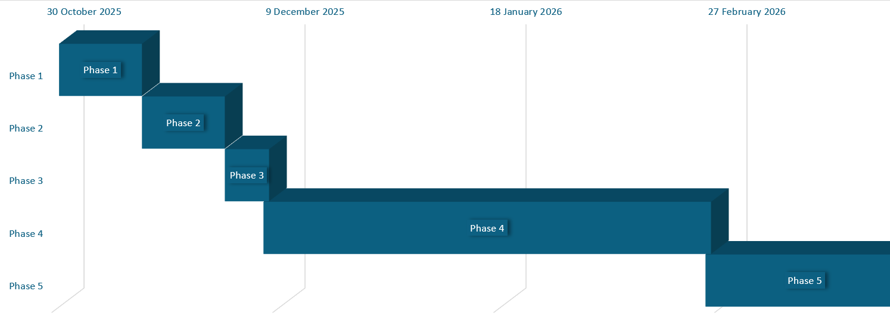

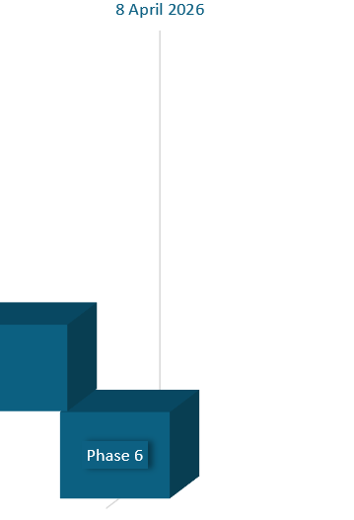

3.3 Milestones
Honeynets running
honeynet infrastructure is fully configured, deployed and operational. All honeypots are live, network monitoring is in place, logging is functioning and initial test traffic has been captured (to verify setup).

Dashboard completion
The dashboard is fully built, data feeds from the honeynets and other sources are connected, visualisations (charts and Diagrams) are working. I can move onto refining the dashboard in greater detail throughout the project.

Log collection
Elk stack is successfully configured to feed logs into Kibana(dashboarding tool).
Logs have successfully been backed up and accessed at the end of honeynet evaluation. Storage processes are in place and we have sufficient log volume to proceed with analysis.

Analysis
Logs have been processed and examined, compare attack metrics such as volume, type and timing across providers and regions, investigate attack exposure on different providers and identify unique exploits or anomalies. Refer to journal and link global events with regional abnormalities that occurred in near chosen data centres. Refer to research questions and hypotheses.

Final report
Compiled a comprehensive report addressing all content and objectives of report, ensure content is referenced correctly and conclusions are delivered.

Analysis
My analysis will commence with the formulated research questions, followed by a set of subsidiary questions to support the investigation. I will test several hypotheses throughout the study. Upon the completion of the honeynet deployment and receipt of all log data, I will evaluate aspects such as attack types, attack volume and complexity, and whether attacks are prolific or persistent. I will then address each research question and hypothesis, drawing comparisons across different providers, geographic regions and provide diagrams and graphs from my dashboard to support these comparisons.

5. References
[1] Cukier, Berthier, Panjwani, Tan. (2006). A Statistical Analysis of Attack Data to Separate Attacks . In Proceedings of the 2006 International Conference on Dependable Systems and Networks (DSN’06). IEEE. 10.1109/DSN.2006.9
[2] Spitzner, L. (2003). Honeypots: Tracking Hackers. Addison-Wesley.
[3] Zdrnja, B., et al. (2008). Observing Internet Attacks Using Low-Interaction Honeypots. IEEE Transactions on Information Forensics and Security.
[4] Almeshekah, M., et al. (2015). Designing Deception: The Role of Human and Technical Factors in Deceptive Security Tools. IEEE Security & Privacy.
[Honeypot] Robinson, S. (2025) ‘What is a honeypot? How it protects against cyberattacks’, SearchSecurity, TechTarget, 11 Feb. Available at: https://www.techtarget.com/searchsecurity/definition/honey-pot
[Modern Honey Nets] Franscella, J. (2016) ‘How to Make Your Modern Honeypot an Enterprise Defense’, Anomali Blog, 31 May. Available at: https://www.anomali.com/blog/how-to-make-your-modern-honeypot-an-enterprise-defense

